Introduction
This report focuses on Exploratory Data Analysis (EDA) and its feature engineering in the Student Habits dataset. Through the discussion, it is tried to explore which factors are related to students' test scores, how the combination of these factors affects the scores, and what patterns students who get good grades usually have.

Dataset Introduction
The student habits dataset is referenced from Kaggle [1]. This is a simulated dataset exploring how lifestyle habits affect academic performance in students. With 1,000 student records and features including study hours, sleep patterns, social media usage, diet quality, mental health, and more - against their final exam score.

EDA
The main questions to answer in the EDA section are:
- Are there missing/duplicate values in the dataset?
- What are the overall metrics (mean, maximum, minimum, etc.) for each habit and final exam score? How are they distributed? (For example, is it normal, skewed, or something else?) Are there any outliers?
- Is there a correlation between each habit and the final exam score?
- Are there other habits that are correlated with each other? For example, is the amount of time spent studying correlated with the amount of time spent sleeping?
- Are there specific groups of students or patterns that are associated with high or low academic performance?

Data Overview and Distribution Analysis
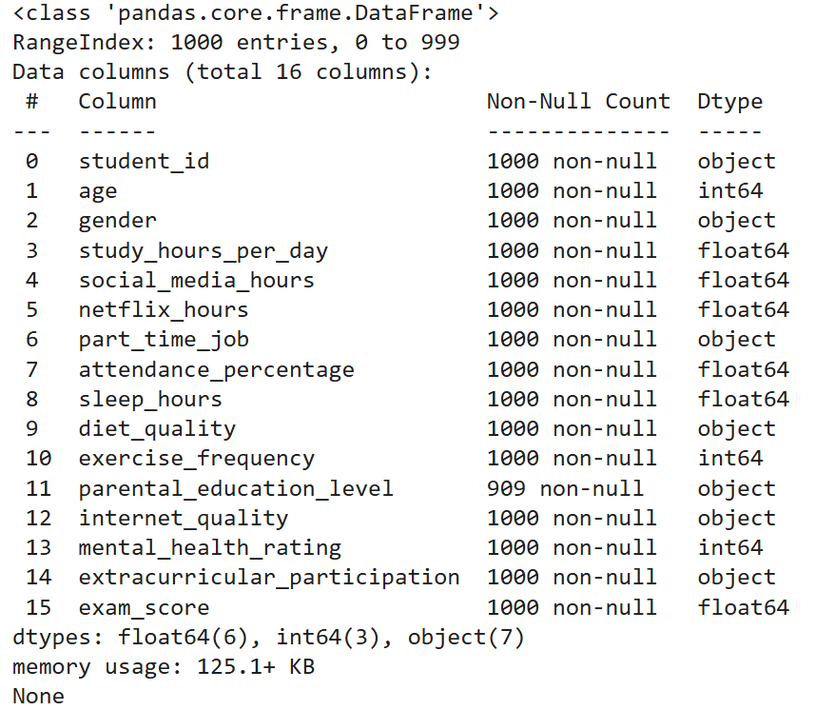
Figure 1 Information of Dataset
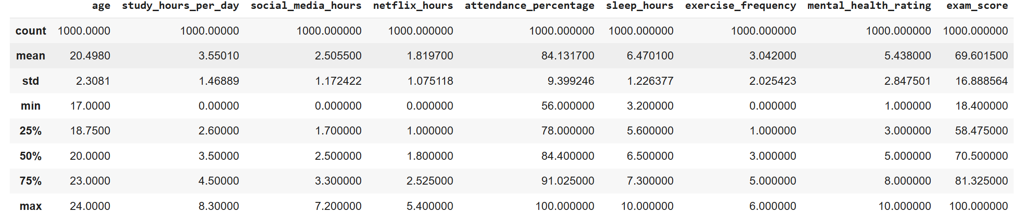
Figure 2 Describe of Dataset
First, let's look at the information of the dataset. As shown in Figure 1, about 9.1% of the data in the `parental_education_level` column is missing, and there are no duplicate records in the dataset.
From the descriptive statistics (Figure 2), it can be seen that the average age is 20.5 years old, the standard deviation is 2.3, and the range is between 17 and 24 years old.
The average study time (study_hours_per_day) is 3.65 hours, and the standard deviation is 1.47, indicating that there are significant differences in students' study habits. The average social media usage time (social_media_hours) is 2.61 hours, while the average Netflix viewing time is 1.82 hours, indicating that students are more diverse in their time allocation for entertainment activities.
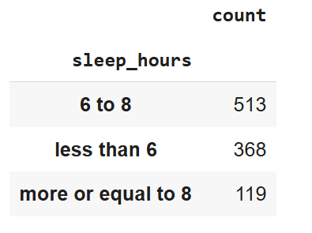
Figure 3 Counting of Sleeping Hours
The average sleep time is 6.47 hours. According to the sleep time counting (Figure 4), most students sleep for 6 to 8 hours. If 8 hours is used as the standard, this may indicate that most students do not get enough sleep, but if 6 hours is used as the minimum standard, it is in line with the sleep pattern of students.
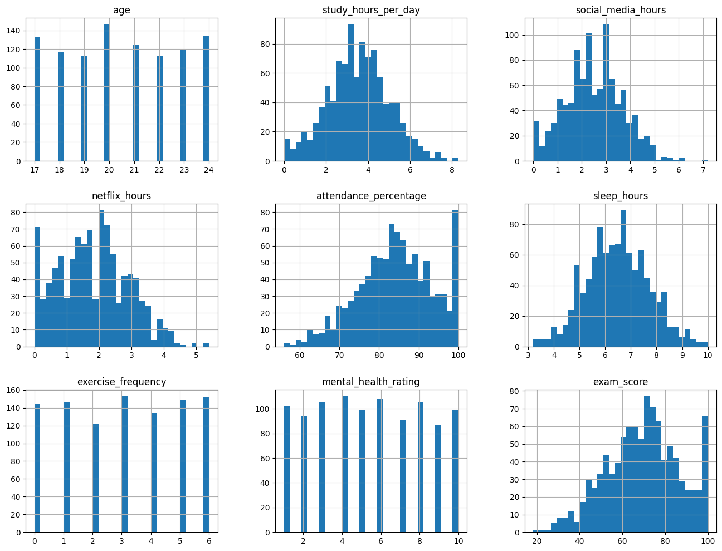
Figure 4 Distribution of Numerical Variables
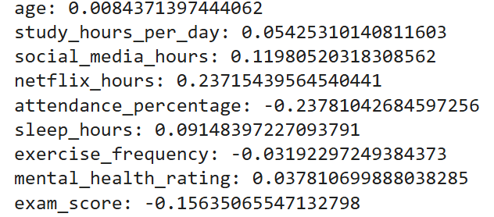
Figure 5 Skewness of Distribution of Numerical Variables
From the distribution plots (Figure 5) and skewness (Figure 6), we can see that the numerical variables of the dataset show a relatively normal distribution (skewness between -0.5 and 0.5).
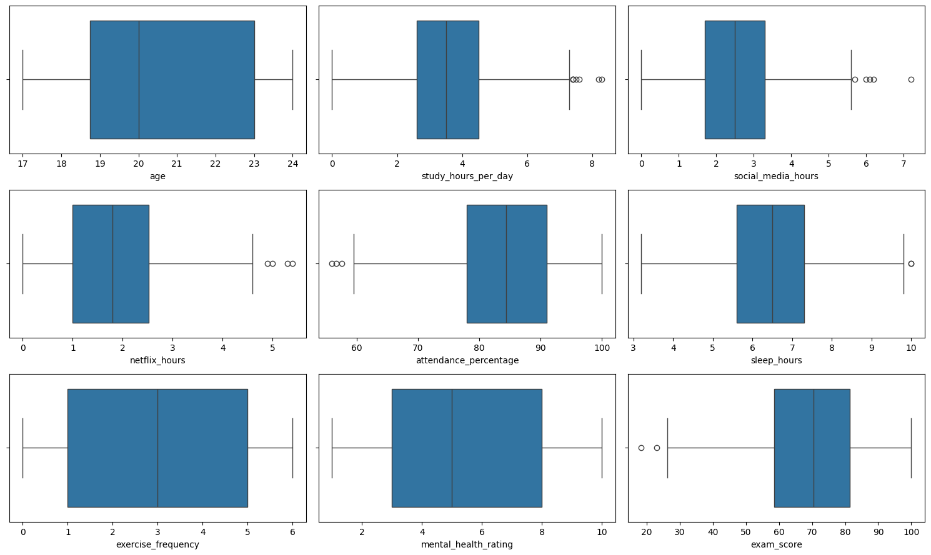
Figure 6 Boxplot of Numerical Variables
From the box plot analysis (Figure 7), it can be seen that most numerical variables have some outliers. In particular, there are obvious upper-end outliers in terms of study time, social media usage time, and Netflix viewing time, indicating that a few students have invested extreme time in these activities.
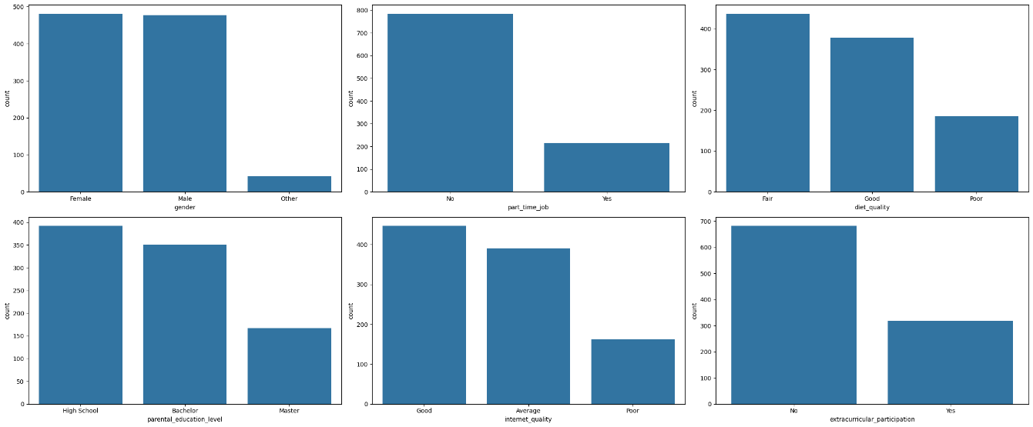
Figure 7 Counting of Category Variables
The bar plot of categorical variables shows varying degrees of uneven distribution, which may have an important impact on academic performance. It will be further discussed in the hypothesis testing section.

Correlation Analysis Between Habits and Exam Scores
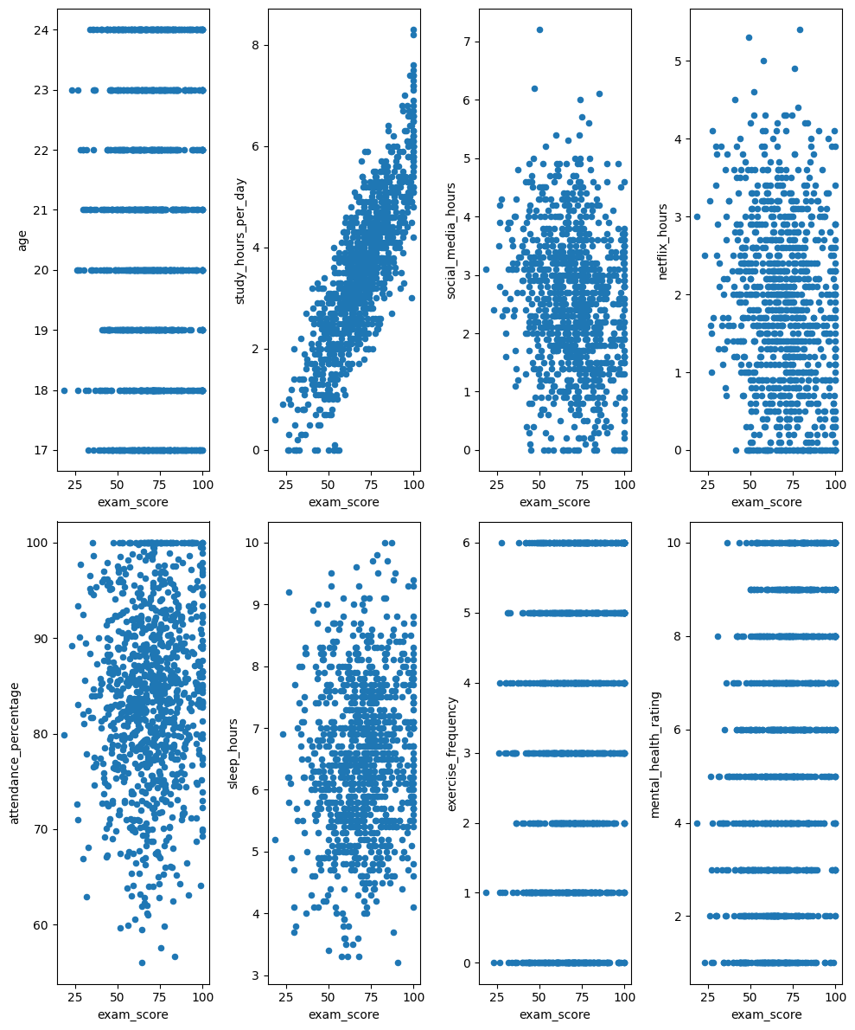
Figure 8 Scatter Plot of Numerical Variables
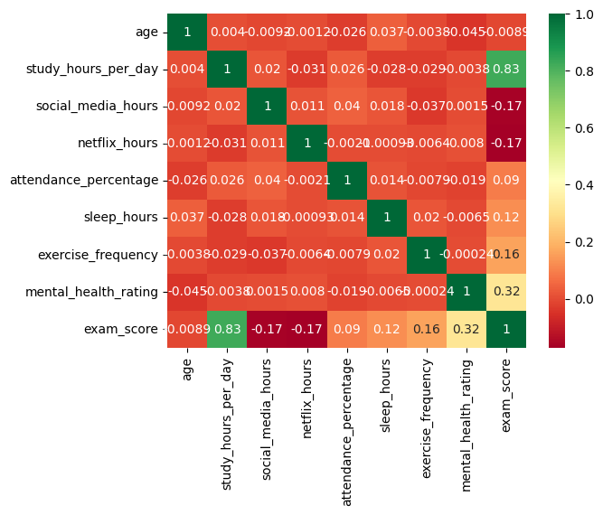
Figure 9 Heatmap of Numerical Variables
It is clear to show from the correlation heat map, there is the strongest positive correlation between study hours per day and exam scores, with a correlation coefficient of 0.83, which is the most significant correlation among all variables. This finding is consistent with the basic intuition that spending more time in study generally leads to better academic performance.
Mental health rating also shows a moderate positive correlation with exam scores (r=0.32), which may indicate that a good mental state has a positive impact on academic performance. Exercise frequency shows a weak positive correlation with the exam scores (r=0.16). Although the correlation is not strong, it suggests that moderate physical exercise may help improve academic performance.
Both social media usage time (social_media_hours) and Netflix viewing time (netflix_hours) show a negative correlation with exam scores (r=-0.17), indicating that entertainment activities may distract students and affect learning outcomes. The correlation between sleep time (sleep_hours) and test scores is weak (r=0.12), which may be because sleep quality is more important than sleep duration.
The correlation between attendance (attendance_percentage) and test scores is 0.09, which is weak but still positive, this indicates that class participation may have certain positive effect on academic performance. There is almost no correlation between age and exam scores, which indicates that within this age range, age differences have little effect on academic performance.
Although most habits are not highly correlated with the exam scores, the impact of these habits can still be further discussed in the hypothesis testing section.

Correlation Analysis Between Different Habits
Through the analysis of the correlations heatmap between the habit variables, we found some interesting patterns. First, the relationship between study time and other variables is relatively independent, which indicates that study habits may be a relatively independent behaviour pattern and are not directly affected by other life habits.
There is no significant correlation between social media use time and Netflix viewing time (r=0.02), which indicates that students may have different preferences between different types of entertainment activities.

Student Group Pattern Analysis and Hypothesis Testing

Hypothesis Testing of Category Variables
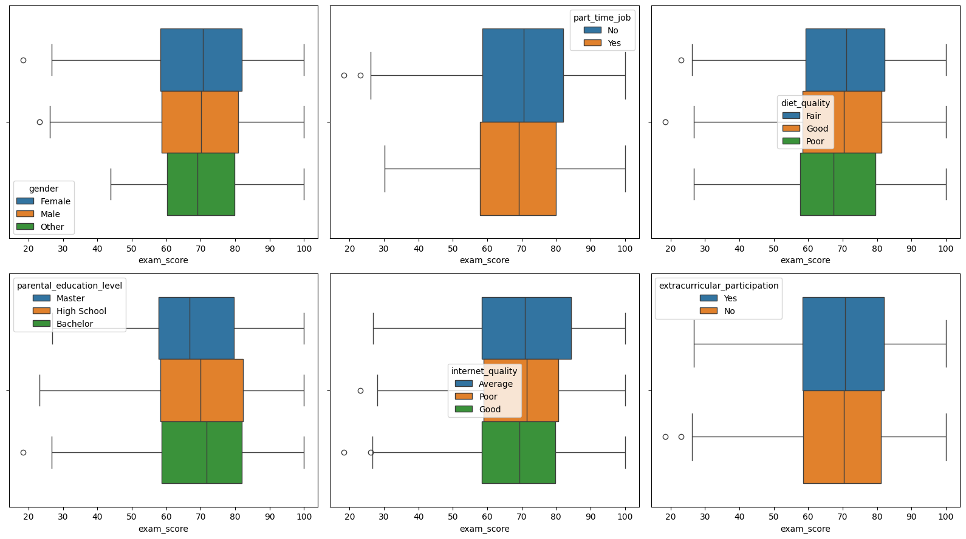
Figure 10 Boxplot of Exam Score under Category Variables
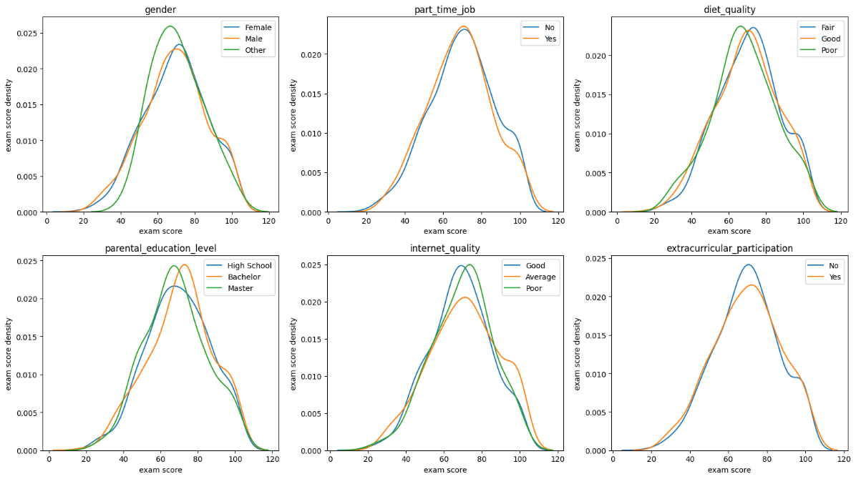
Figure 11 Distribution Plot of Exam Scores under Category Variables
With the help of the correlation heat map and the box plot and distribution plot of the categorical variables (Figures 10 and 11), we can conduct some hypothesis tests to check whether the categorical variables have a significant impact on the test scores. The significance level α is set to 0.05, and for the parental_education_level column with null values, we delete the null values ​​before conducting the hypothesis test.
For each categorical variable, the null hypothesis in the hypothesis test is to assume that there is no significant difference in the test scores under different categories of the categorical variable, and the alternative hypothesis is that there is a significant difference. Taking gender as an example, the null hypothesis is to assume that there is no difference in the test scores of males, females, and others (µ_{male} = µ_{female} = µ_{other}), and the alternative hypothesis is to assume that there is a difference between them (µ_{male} ≠ µ_{female} ≠ µ_{other}). In addition, for each categorical variable, if its number of categories is 2, a two-sample t-test is performed to compare the differences in test scores between different groups; for variables with more than two categories, a one-way analysis of variance (ANOVA) is used.
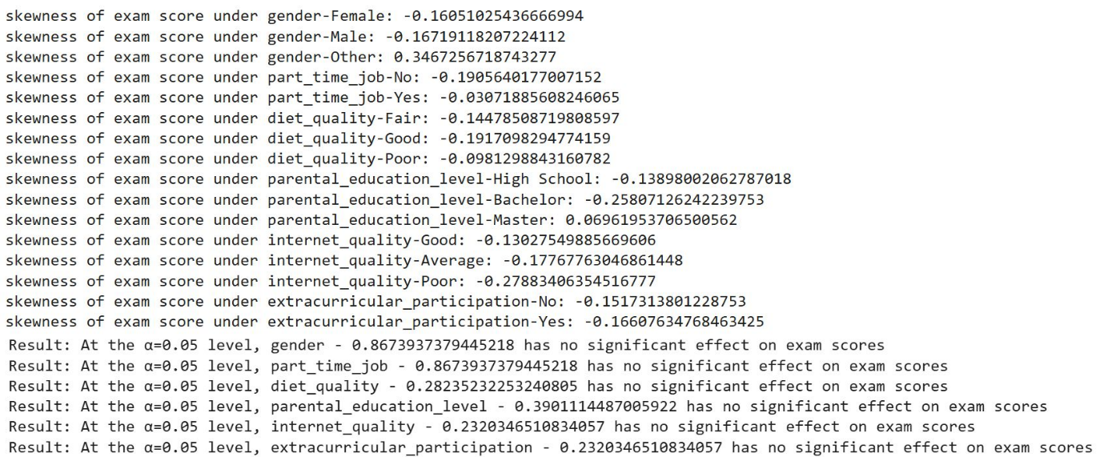
Figure 12 Skewness and Results of Hypothesis Testing - 1
According to the results of hypothesis testing, we can see that all the category variables do not have significant effect on exam scores.

Pattern Analysis and Hypothesis Testing of Numerical Variables
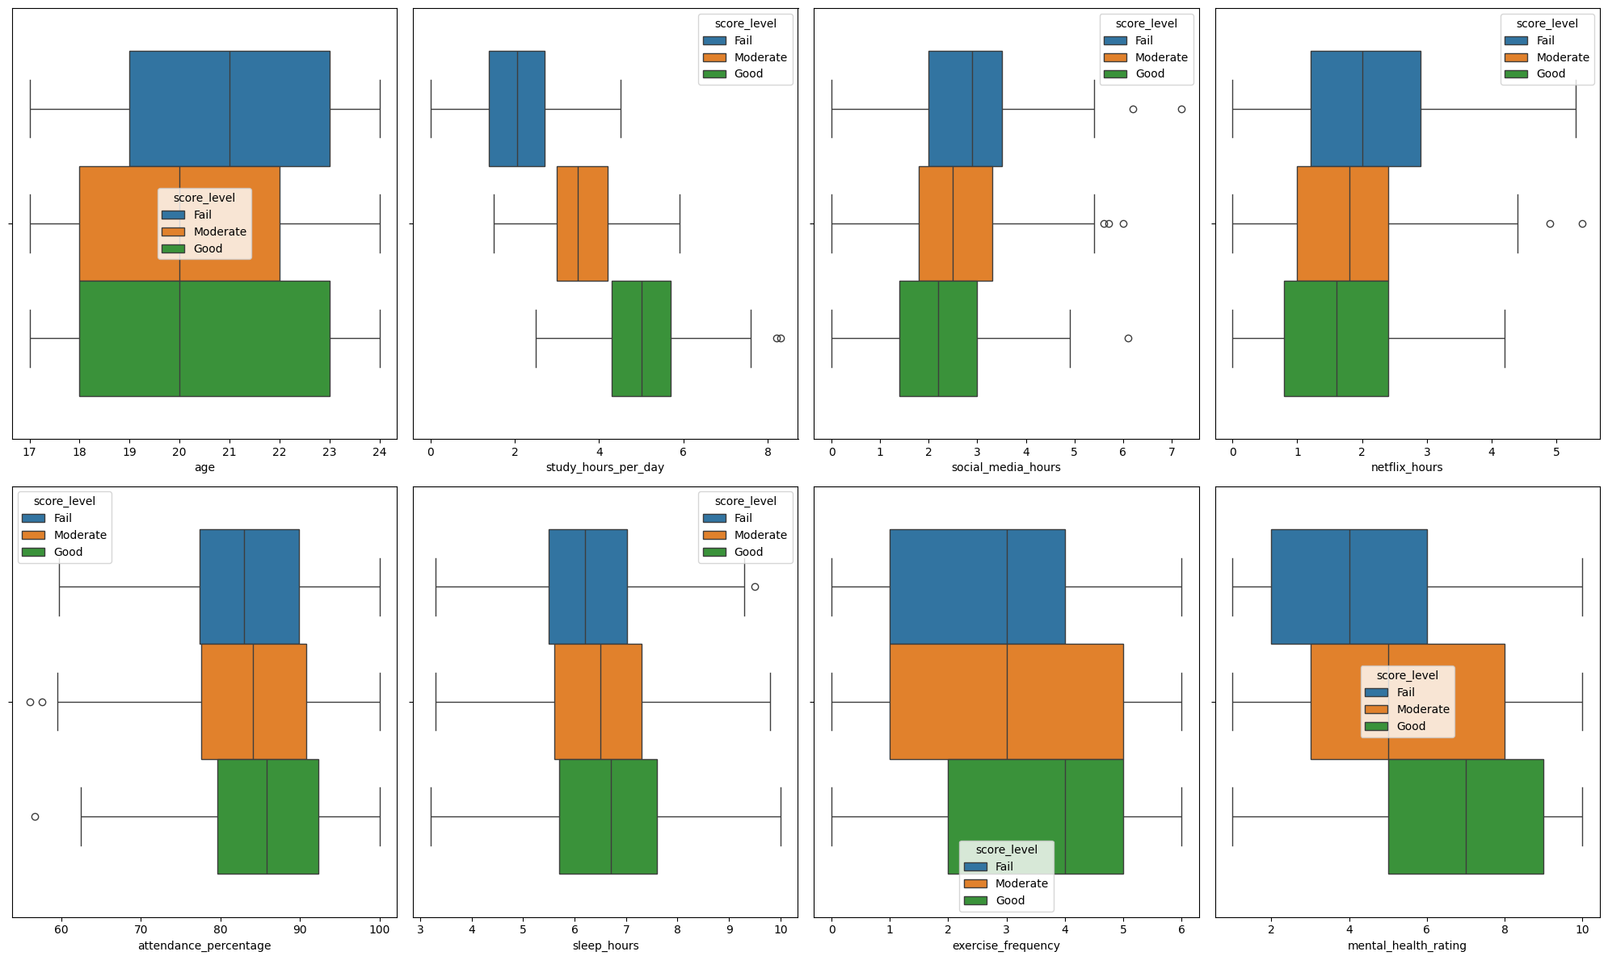
Figure 13 Box plot of Numerical Variables under Different Exam Score Level
Here, the exam scores are separated into 3 levels: `Fail` represents scores under 60; `Moderate` represents scores from 60 to 80; and `Good` represents scores from 80 to 100. This analysis aims to examine the patterns of students in different score level groups. The key question is: Do students with `Good` score levels have significantly different habits compared to students with other score levels?

With the help of box plots (Figure 13), we can clearly observe several important patterns. Students in the `Good` score level group show a lower median for entertainment hours (social media and Netflix hours) and higher medians for other numerical variables (except for age). In other words, they spend less time on entertainment activities like social media and Netflix. In other words, the box plots reveal that high-performing students tend to spend more time studying, have better attendance rates, get more sleep, exercise more frequently, and maintain better mental health ratings.
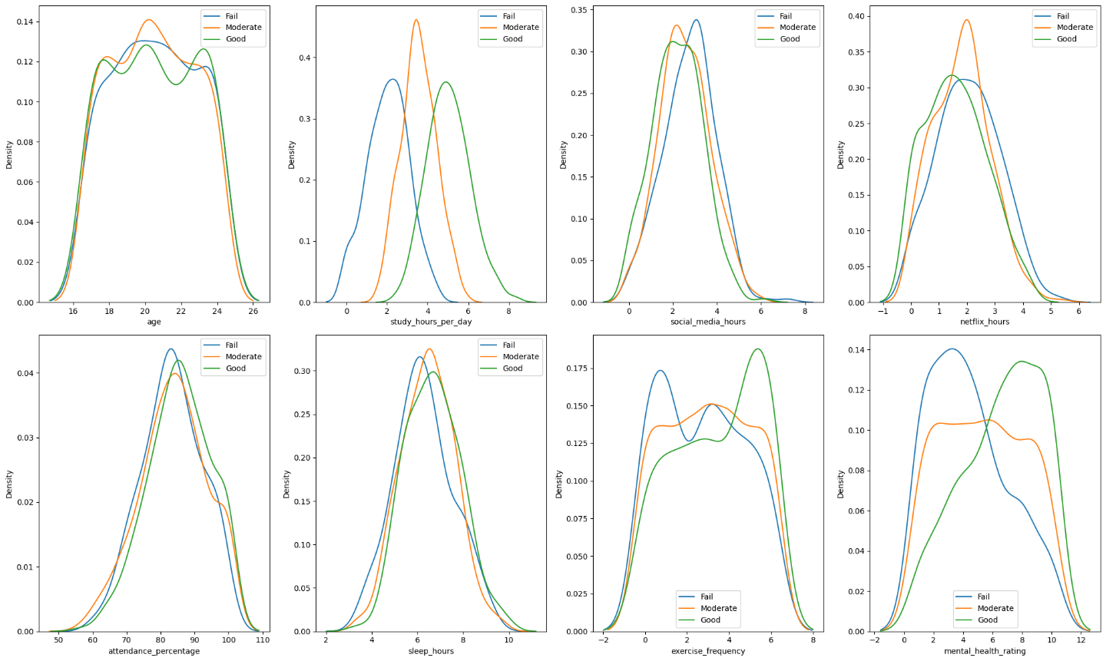
Figure 14 Distribution plot of Numerical Variables under Different Exam Score Level
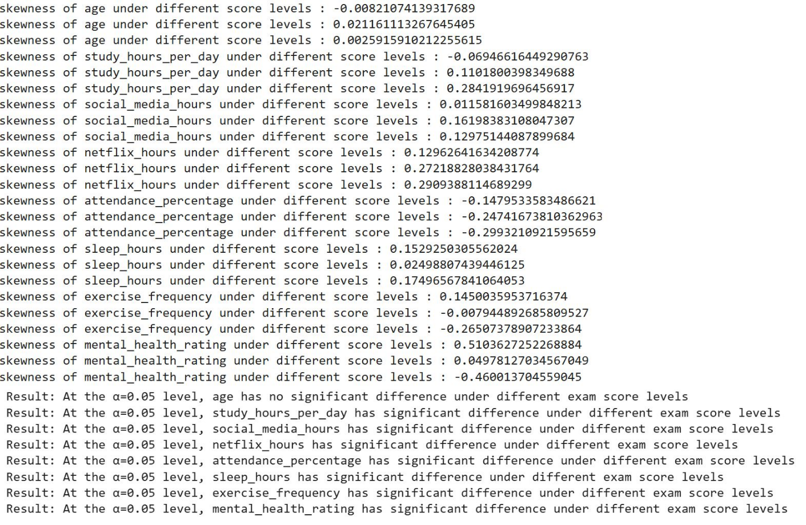
Figure 15 Skewness and Results of Hypothesis Testing – 2
Based on the box plots and distribution plots (Figure 14), hypothesis tests can be conducted to determine whether there are statistically significant differences between different score levels for each numerical variable. The methods for conducting these hypothesis tests are the same as for categorical variables.
From the results of the hypothesis tests (Figure 15), we can see that, except for the age attribute, all other numerical variables show significant differences between different score levels. This finding suggests that there are indeed significant differences in the habits of high-performing and low-performing students, where although the overall correlation between exam scores and individual numerical variables may be low, students with `Good` level exam scores still have better study habits overall.

EDA Conclusion
First, the dataset contains records of 1,000 students and is of good quality overall. Only the parental_education_level column has 9.1% missing values ​​and no duplicate records. All numerical variables are relatively normally distributed, but there are some outliers, especially in terms of study hours and entertainment hours.
Second, the strongest positive correlation is found between study time and exam scores, which confirms the basic theory that more time spent studying usually leads to better academic performance. For other variables, although the correlation between a single variable and exam scores may not be high, when multiple habit factors are considered together, their impact on academic performance becomes significant. By dividing students into three levels according to their scores (Fail, Moderate, and Good), we found that all numerical variables, except age, were significantly different across different score levels, where the `Good` student group shows better study habit patterns. These findings provide an empirical basis for developing educational and student support strategies.

Features Engineering

Handling Missing Values
In the parental_education_level column, there are about 9% of the records are missing. Therefore, It is just filled it with the mode. The mode is the category with the most occurrences and filling it in can maintain the original distribution of the entire column.

Encoding
It is used a small dictionary to map ordinal category variables such as `Poor-Fair-Good` to integers from 1 to 3, which not only retains the order information but also avoids too many dummy variables. The gender, part-time job, and extracurricular activities columns have no obvious order, so it is used `get_dummies` to turn them into 0/1 columns.
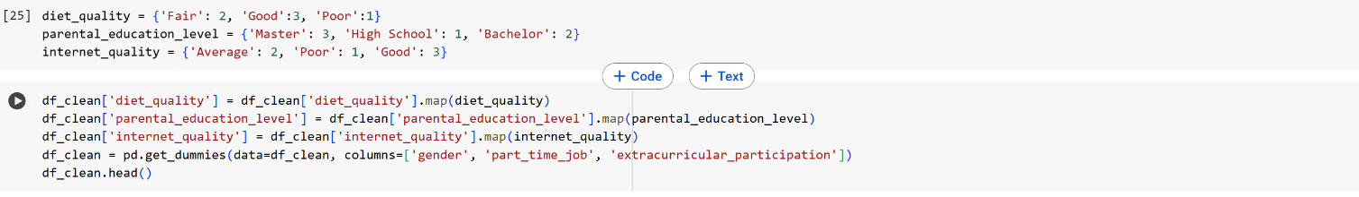
Figure 16 Code of Encoding Category Variables

New Features
It is added two types of new features. The first type is to add social media hours and Netflix hours to get entertainment hours, because they are essentially "entertainment time", and the combination can more intuitively show how much time students spend on entertainment.
The second type is to divide the exam score into levels (Fail, Moderate, Good), just like what is done in the EDA section, and perform a Z-score on the study time of each student in his/her group of scores, to get `study_hours_per_day_Dev_score_level`. In this way, it can show who has studied more than the average and who has studied less than the average in the same grade level, which can better reflect the relative degree of effort than simply the total study time.

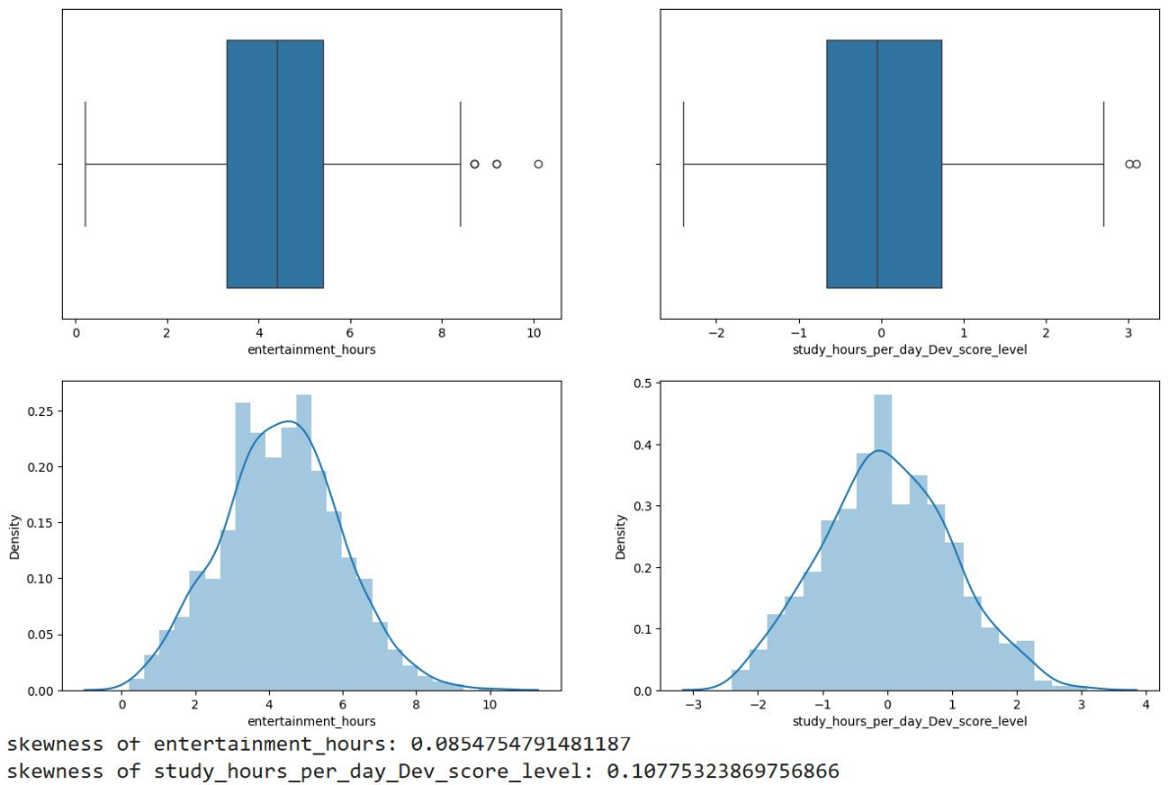
Figure 17 Box plot, Distribution plot and skewness of New Features
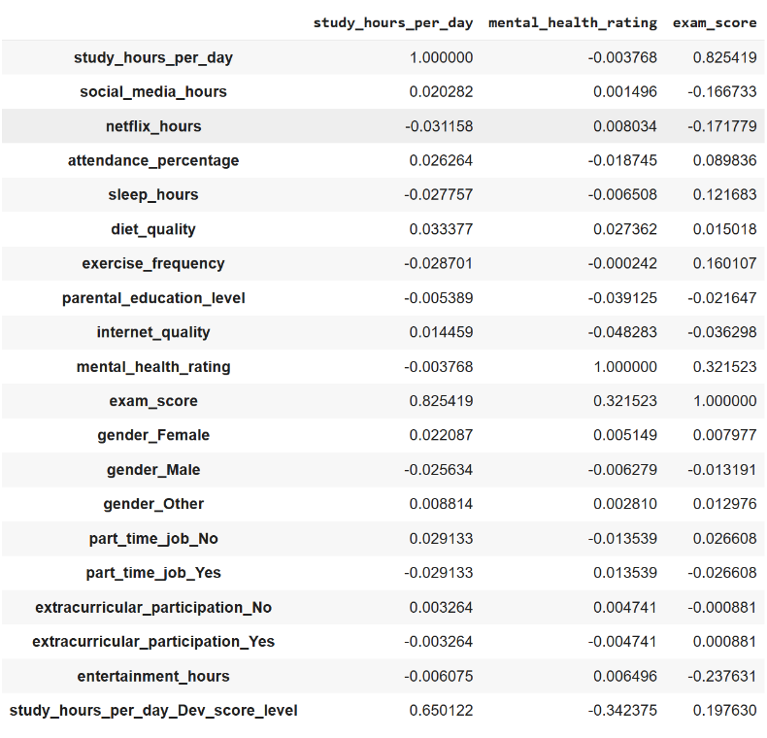
Figure 18 Correlation between New Features and Exam Score
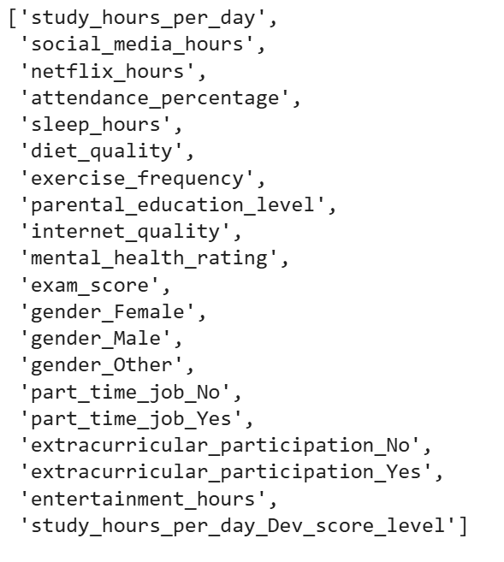
Figure 19 Final Select Features

References
[1] J. Nath, "Student Habits vs Academic Performance," Kaggle, 2024. [Online]. Available: https://www.kaggle.com/datasets/jayaantanaath/student-habits-vs-academic-performance.

